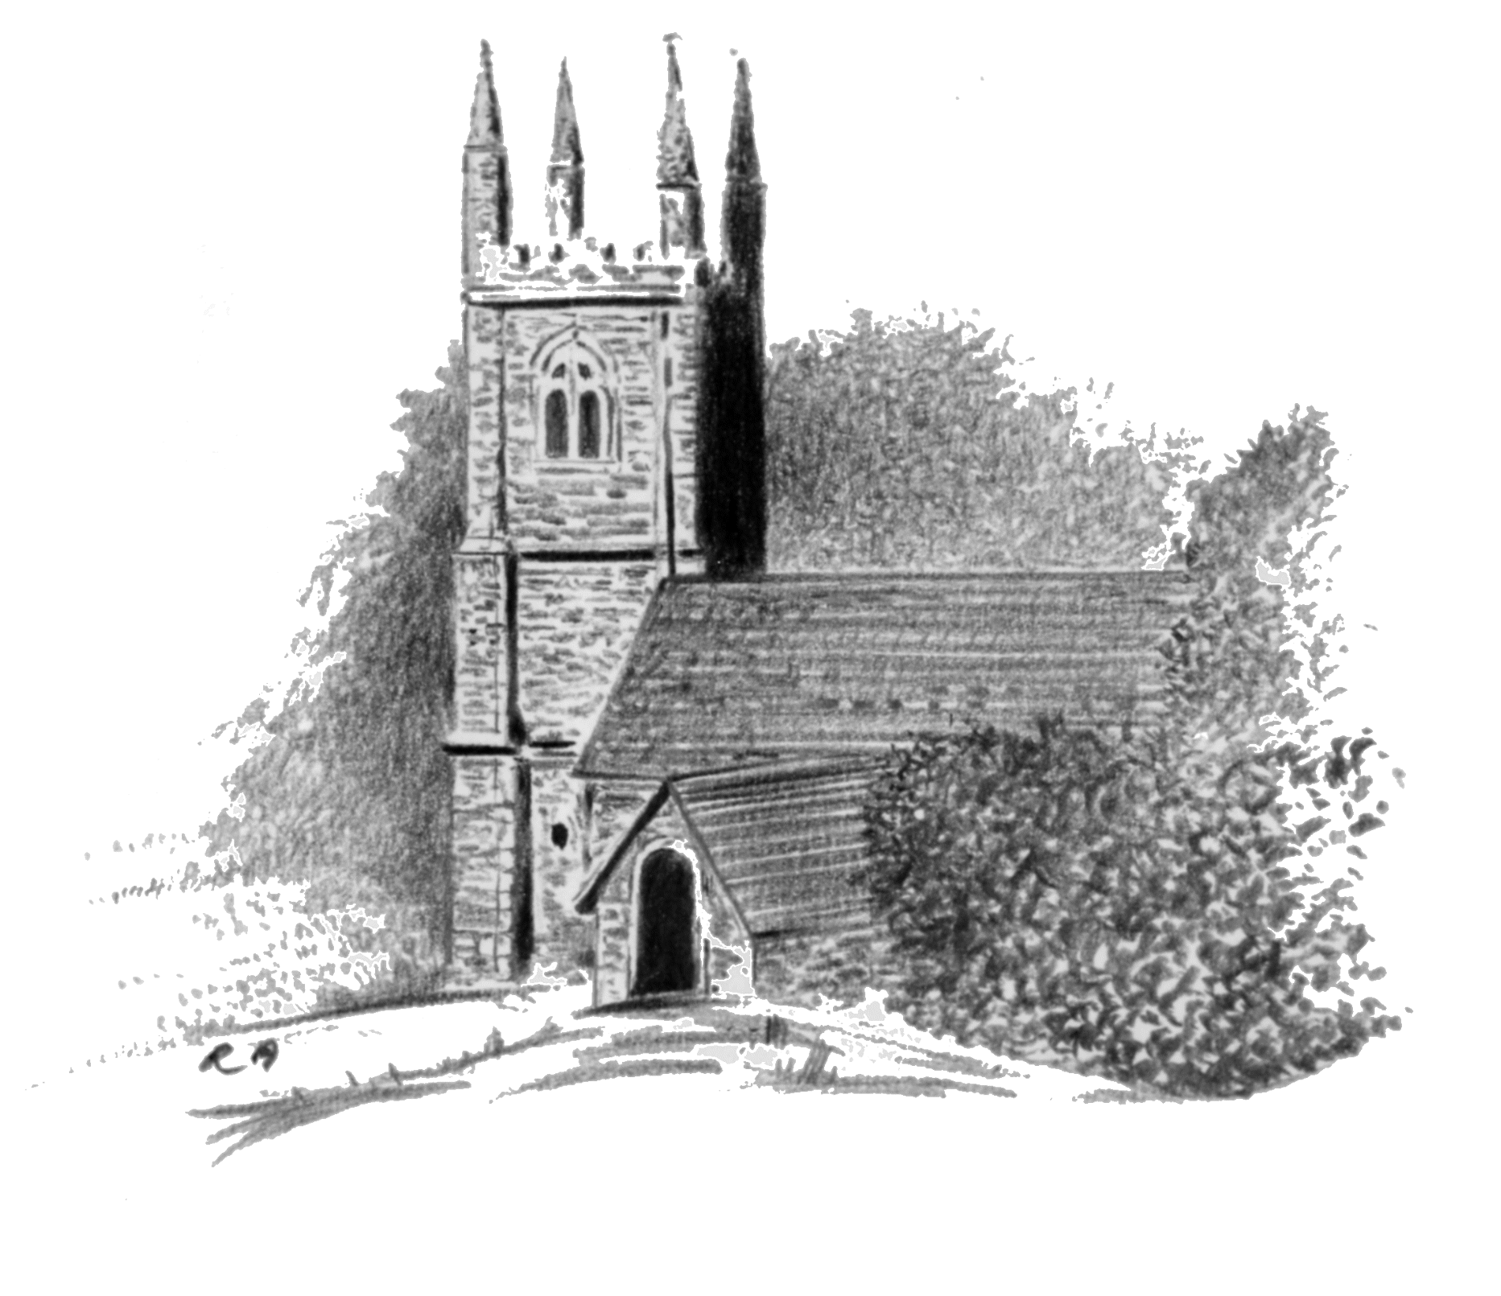
St Mary’s Church - Sampford Spiney

Sampford Spiney Parochial Church Council
c/o Rose Villa, Bedford Road, Horrabridge, Nr Yelverton, Devon PL20 7QW
Tel: 01822 859098 Mob: 07770 938287 E Mail: simonpatrickhill@outlook.com

April 2023

THOUGHTS ON SUSTAINING YOUR PARISH CHURCH

Introduction
Those of you who attended the 2022 Christmas Extravaganza will have heard me expressing my concerns for the medium to long-term future of St Mary’s. I outlined the challenge as:
- Continuing to Pay Our Way - 2022 was a good year in terms of fundraising and we also received a modest legacy. This was due to the really hard work of a small group of loyal supporters and a bit of good luck. However, I pointed out that all that would do was pay our Running Costs for another year and allow us to maintain two year’s Running Costs in reserve. I also mentioned that it would allow us 12 months breathing space to gather our thoughts about how we were going to manage church affairs in the medium to long term.

- Managing the Church - underlying the above message was the further concern that those doing the day-to-day work were not getting any younger and that we were effectively “one brick thick”. The incapacity of one individual (Lay Chairman; Church Warden; Treasurer for example), even temporarily, would give us considerable difficulty. We are already very dependent on volunteer help who again are not getting any younger.
So Where Are We?
- Service Pattern - we are lucky in that we are still able to hold church services on three Sundays per month and occasional midweek offices. We also have the usual mix of christenings, marriages, funerals and interments supported by organ music.

- Bells - we have a vibrant group of bell ringers supporting our services and others who seek the opportunity to ring what is, by repute, the best light peal in Devon.

- Maintenance - we have the support of volunteers who help us maintain the church, its bells, and its environs. When we need more professional help, we can call upon an expert local builder and electrician to help us deal with the challenge of maintaining an historic, Grade 1 listed church.

- Fabric - we believe the fabric and electrical circuit are good shape and expect this will be confirmed by our mandatory five yearly survey due this July. That said, this Quinquennial Review creates an upward blip in the annual budget of around £1200 to pay for the building and electrical surveys, not to mention any essential maintenance work which may emerge and need to be addressed within 12 months.

- Fundraising - as far as fundraising goes, historically we have relied largely on a stable of events organised by members of the Parochial Church Council (PCC) and a small core of dedicated parishioners. Last year this process realised around c£6000 to try to offset the financially detrimental effects of Covid; in most years we would expect to raise c£4000.

- Balance of Running Cost - historically this has come from collections and associated Gift Aid on Small Donations Scheme (GASDS); occasional donations and associated Gift Aid; a limited amount of regular giving and associated Gift Aid; Parish Council contribution; and fees from weddings, funerals, interments etc. As a charity exempted from registration, we are entitled to claim Gift Aid which adds 25% to any donation we receive.

- In Summary, we need to generate around £10000 per annum to keep the show on the road. In big handfuls:

- Parish Share paid to the Diocese as our contribution to the provision/running cost of a priest - £4000.
- Buildings Insurance – £2000.
- Electricity - £1500.
- Maintenance – £750.
- Organist - £600.
- Contribution to Mission Community Running Cost - £450.
- Flowers/candles etc - £150.
- Bank Charges - £60
- Quinquennial Review - £1200 (only in 2023/2028 et seq).

So Where Would We Like To Be?
There are many churches which have already had to reduce their number of services due to lack of support or priests - we are not yet in that position, but the certainty of a reducing priest headcount will force this upon us in due course. It is worth noting that our Parish Share would not automatically/pro rata reduce if this situation became reality and we would still need to insure, heat and maintain the building.
That said, your PCC has been working with representatives of other churches within the Mission Community to keep alert to alternative options for running churches. Clearly, the holy grail in the medium to long term is to achieve a position where the costs involved adjust to the service pattern on offer rather than remaining constant. There is at least one church in Devon which appears to have managed this and we are talking to them. Clearly, there are other options short of closure and the Mission Community is looking into how they are achieved and sustained. As an example, one of the options is to become a “Festival Church” whereby services are only held on the key dates in the church calendar (Christmas; Easter etc) plus christenings, marriages, funerals and interments. While this looks like a neat solution, we have yet to identify exactly how the insurance, maintenance etc is sustained – we can all imagine the rate at which an unheated St Mary’s would decay in such a scenario!
As I said above, we are not yet in a position where we are under pressure to cut back on our pattern of services, but I just thought I would expose some of the issues if only to make the point that we are not just sitting on our hands waiting for the roof to fall in!
Your PCC recommends that we should continue with the current Service Pattern (with the minor change to an Evening Service on the First Sunday of the month vice the current arrangement of alternate Mattins and Evensong) until such time as outside factors such as a reduction in priests impacts upon us. Clearly, by remaining engaged with and contributing to consideration of future structures and service patterns at the Mission Community level, we can influence and be fully aware of any changes under consideration.
Implications of the Status Quo
This brings me back to where I started – continuing to pay our way and managing the church.
Taking the second point first, it doesn’t matter much if we have a church in good fettle and an engaged worshipping community if we don’t have the volunteers to run the operation. In essence, I would like to see us reinforcing the PCC rather than the current members simply taking on additional roles as others stand down.
Specifically, I would like to recruit people to the PCC to learn the ropes in the first instance and on the understanding that they were willing to take on more substantive roles in the future. A robust PCC would look something like:
- Lay Vice Chair - currently filled

- Church Warden 1 – currently filled

- Church Warden 2 - vacant

- Treasurer – currently filled

- Minutes Secretary - vacant

- Deanery Synod rep - currently filled

- Member 1 – currently filled/shadows Church Warden 1

- Member 2 – vacant/shadows Lay Vice Chair

- Member 3 - vacant/shadows Treasurer

As far as paying our way is concerned, I worry that over time we will slowly but surely run out of cash.
As far as events go, they are hugely well supported both from within and without the parish but running a programme on the scale of last year is not sustainable in the long term unless we reinforce the PCC and volunteer base.
Living in the hope of another legacy does not make much sense. All the charities I have been involved with over the years made no assumptions in respect legacies and planned to put any they received into reserves rather towards running costs.
We do reasonably well via the collection plate and contributions put into the collecting box in the church by random visitors. We have recently installed a QR code in the church so that casual visitors can donate via their online accounts.
Where we are weakest is in the area of planned giving – a core of individuals willing to contribute regularly, whether it be large or small amounts.
One final small thought – the church has an account at Drake Auctions; if you are selling things there perhaps you might consider donating all or part of the sale price………they normally waive the commission fee for charities.
So What is the Purpose of this Letter?
To encourage you to:
- Firstly, consider joining the PCC with a view to creating some depth in the short term and to relieve some of those currently in post in the medium term.

- Secondly, consider making a regular contribution, however large or small, to the running cost of your parish church if you are not already doing so. I am very aware that a number of you already contribute, and we are most grateful for your support. This would ease the pressure on your PCC and its small band of willing helpers to generate fundraising events at the current rate. Clearly there are other ways to help keep the church going financially – you could run a fundraising event for us; make a one-off donation; or even leave a legacy. I have attached a donation form to this letter which I hope covers all bases and reflects the HMRC recommended wording in respect pf Gift Aid.
Events Coming Up
Finally, I thought that I would use this opportunity to promote some events taking place over the summer:
- 8 May @ at Midday – Bank Holiday Rounders Match at Playing Field (site of the annual sheepdog trials); this is more a Parish Council inspired rather than a church event. Details are in the attached poster.

- 20/21 May - Church Spring Clean and gable end painting depending on the weather!

- 31 May - Coffee Morning @ Rose Villa, Bedford Road, Horrabridge @ 10.30am - £3.50 per head with raffle and cakes for sale

- 29 June @ 7pm - Cocktails, Canapes and Comedy by Candlelight @ St Mary’s Church – tickets are £15 to include entry, canapes, joke and first drink/pay as you go thereafter with cocktails at £5 or mocktails at £3. Tickets available for simonpatrickhill@outlook.com or katie.warnes@btinternet.com.

- 26 August – Sheep Dog Trials @ Playing Field on Plasterdown.

In Conclusion
I hope that I have reflected our predicament in an objective way without being unnecessarily alarmist - do get in touch if you have any thoughts or questions.

Enclosures:
- Rounders Poster.
- Donation Form.

Wondering what to do on Coronation Bank Holiday?

Bank Holiday Rounders Match
8th May 2023 at 12 noon
@ Playing Field on Plasterdown (SX518718)
Free Entry
Bring Your Own Chairs and Picnic
Cash Bar on site (and portaloos!)
Eight teams of Eight/24 Balls per team
Make up a team and register in advance with simonpatrickhill@outlook.com or 01822 859098 or simply come along and hope for the best!
Children’s races and Tug o’ War Finale between Farmers and the Rest

Why Rounders?
On Victory in Europe (VE) Day 1945 the people of Sampford Spiney celebrated with a rounders match for which a Challenge Shield was awarded to the winners. The shield vanished only to re-appear recently in the bottom of a box of dusty church records! Plasterdown Grouped Parish Council decided to re-invigorate this event to celebrate the coronation of King Charles III on the anniversaries of VE Day and 50 years since the formation of the Parish Council.

